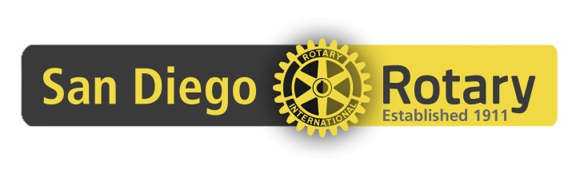
Club 33 Bequest Society Members,
Please remember to update your wills and estate paperwork to change the beneficiary to the Rotary Club of San Diego Foundation. It is important to do so to insure that the funds come directly to the Club Foundation instead of the San Diego Foundation which is where we used to hold our accounts until we re-established our Foundation in July, 2015.
As a reminder, you can include Rotary in your estate plans in many ways — most commonly by making a gift in a will or adding to a will by a document known as a codicil. Alternatively, you might choose to make Rotary the beneficiary of a retirement plan or insurance policy. In most cases, your gift should be directed to the “Rotary Club of San Diego Foundation.”
Here are a few examples of language for your adviser to consider:
- For a general gift of a certain percentage or portion of the estate:
“I give to the Rotary Club of San Diego Foundation _____% of my estate.”

- For a gift of a specific asset:
“I give 500 shares of XYZ stock to the Rotary Club of San Diego Foundation.”

- For a contingent bequest, which takes effect only upon the meeting of certain conditions:
“In the event my spouse does not survive me, I give to the Rotary Club of San Diego Foundation $____ amount.”

- For a residual bequest, which directs all or a portion of whatever remains after all other required amounts are paid:
“I give the rest, residue, and remainder of my estate to the Rotary Club of San Diego Foundation.”

Consult your legal or tax advisors for the tax consequences of all planned gifts and donations.
The Rotary Club of San Diego Foundation Tax ID Number is: 47-1766606
If you would like to know more about giving options, contact Paul at the office at 619-299-3309

